**Industrial Internship Report on**

**”** **Digitally Local”**

**Prepared by**

**[Rachan Kumar P G]**

|  |
| --- |
| *Executive Summary* |
| This report provides details of the Industrial Internship provided by upskill Campus and The IoT Academy in collaboration with Industrial Partner UniConverge Technologies Pvt Ltd (UCT).  This internship was focused on a project/problem statement provided by UCT. We had to finish the project including the report in 6 weeks’ time.  My project was Digitally Local- **Developing a Cost-Effective Digital Marketing Strategy for Local Business Growth**  This internship gave me a very good opportunity to get exposure to Industrial problems and design/implement solution for that. It was an overall great experience to have this internship. |

**TABLE OF CONTENTS**

1 Preface 3

2 Introduction 4

2.1 About UniConverge Technologies Pvt Ltd 4

2.2 About upskill Campus 8

2.3 Objective 9

2.4 Reference 9

2.5 Glossary 10

3 Problem Statement 11

4 Existing and Proposed solution 12

5 Proposed Design/ Model 13

5.1 High Level Diagram (if applicable) 13

5.2 Low Level Diagram (if applicable) 13

5.3 Interfaces (if applicable) 13

6 Performance Test 14

6.1 Test Plan/ Test Cases 14

6.2 Test Procedure 14

6.3 Performance Outcome 14

7 My learnings 15

8 Future work scope 16

# Preface

**Overall Learning Summary – Digital Marketing Course**

Over the course of six weeks, I gained a strong foundational understanding of digital marketing and how it's applied to real-world business scenarios. Here's a comprehensive overview of my learning:

**1. Strategic Thinking in Marketing**

I learned how to define marketing goals and align them with the right digital channels. From identifying the target audience to mapping the customer journey, I now understand how to build a complete digital marketing strategy that supports business growth.

**2. Website & SEO Fundamentals**

I developed skills in optimizing websites for both users and search engines. This includes keyword research, writing meta tags, improving site structure, and analyzing site performance through tools like Google Search Console. I also understood how organic traffic is influenced by search engine algorithms.

**3. Content Marketing & Branding**

I gained hands-on experience in planning and creating content that educates, engages, and converts. This involved learning about content types (blogs, videos, social posts), brand identity, tone consistency, and using tools like Canva for content design.

**4. Social Media Marketing**

I learned the nuances of different social platforms and how to build a content strategy that fits each one. This included understanding engagement metrics, scheduling posts, running paid ads, and optimizing content to increase visibility and reach.

**5. Email Marketing & Lead Generation**

I explored the process of capturing leads, designing email campaigns, and nurturing subscribers through targeted messaging. I also understood how email automation works and how to track performance using open rates and click-through metrics.

**6. Analytics & Optimization**

One of the most important takeaways was learning how to use data to make decisions. I learned how to read analytics reports, track user behavior, and evaluate the success of marketing campaigns through KPIs. This taught me how to optimize strategies based on measurable outcomes.

**7. Practical Tool Usage**

Throughout the course, I became familiar with essential marketing tools such as:

* Google Analytics and Search Console
* Canva for design
* Mailchimp for email marketing
* Meta Business Suite for social media ads

These tools helped me bridge theory with real-world execution.

# Introduction

## About UniConverge Technologies Pvt Ltd

A company established in 2013 and working in Digital Transformation domain and providing Industrial solutions with prime focus on sustainability and RoI.

For developing its products and solutions it is leveraging various**Cutting Edge Technologies e.g. Internet of Things (IoT), Cyber Security, Cloud computing (AWS, Azure), Machine Learning, Communication Technologies (4G/5G/LoRaWAN), Java Full Stack, Python, Front end**etc.

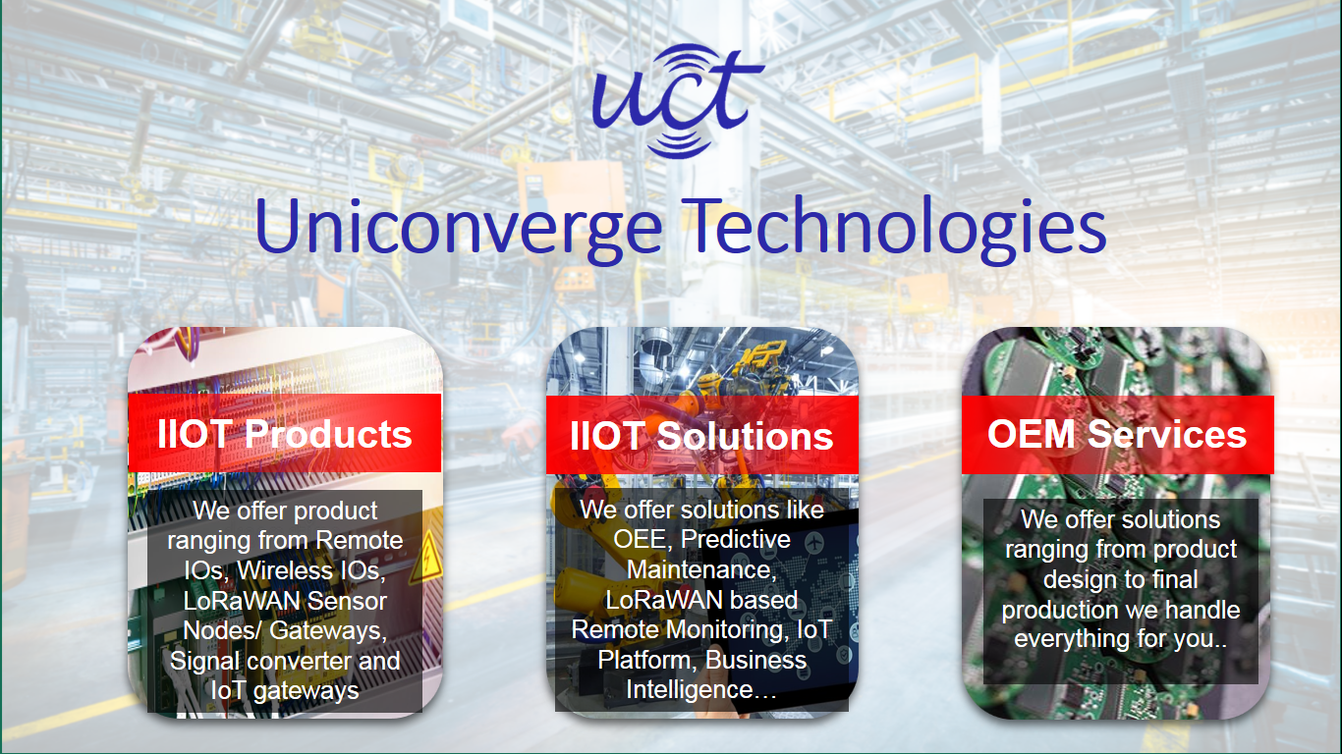

1. UCT IoT Platform **(****)**

**UCT Insight** is an IOT platform designed for quick deployment of IOT applications on the same time providing valuable “insight” for your process/business. It has been built in Java for backend and ReactJS for Front end. It has support for MySQL and various NoSql Databases.

* It enables device connectivity via industry standard IoT protocols - MQTT, CoAP, HTTP, Modbus TCP, OPC UA
* It supports both cloud and on-premises deployments.

It has features to  
• Build Your own dashboard  
• Analytics and Reporting  
• Alert and Notification  
• Integration with third party application(Power BI, SAP, ERP)  
• Rule Engine

 

1. **Smart Factory Platform (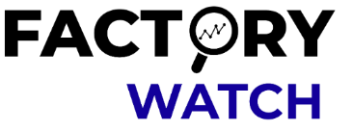)**

Factory watch is a platform for smart factory needs.

It provides Users/ Factory

* with a scalable solution for their Production and asset monitoring
* OEE and predictive maintenance solution scaling up to digital twin for your assets.
* to unleased the true potential of the data that their machines are generating and helps to identify the KPIs and also improve them.
* A modular architecture that allows users to choose the service that they what to start and then can scale to more complex solutions as per their demands.

Its unique SaaS model helps users to save time, cost and money.

 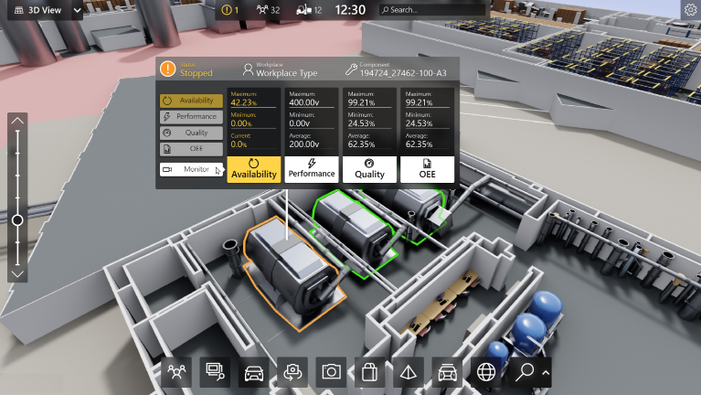

1. 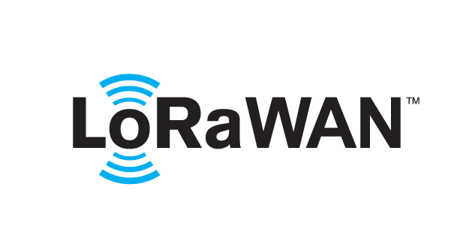 based Solution

UCT is one of the early adopters of LoRAWAN teschnology and providing solution in Agritech, Smart cities, Industrial Monitoring, Smart Street Light, Smart Water/ Gas/ Electricity metering solutions etc.

1. Predictive Maintenance

UCT is providing Industrial Machine health monitoring and Predictive maintenance solution leveraging Embedded system, Industrial IoT and Machine Learning Technologies by finding Remaining useful life time of various Machines used in production process.



## About upskill Campus (USC)

upskill Campus along with The IoT Academy and in association with Uniconverge technologies has facilitated the smooth execution of the complete internship process.

USC is a career development platform that delivers **personalized executive coaching** in a more affordable, scalable and measurable way.

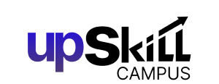

Seeing need of upskilling in self paced manner along-with additional support services e.g. Internship, projects, interaction with Industry experts, Career growth Services

<https://www.upskillcampus.com/>

upSkill Campus aiming to upskill 1 million learners in next 5 year

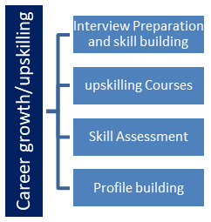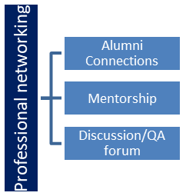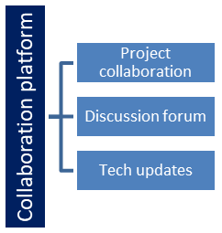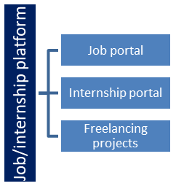

## The IoT Academy

The IoT academy is EdTech Division of UCT that is running long executive certification programs in collaboration with EICT Academy, IITK, IITR and IITG in multiple domains.

## Objectives of this Internship program

The objective for this internship program was to

 ☛ get practical experience of working in the industry.

 ☛ to solve real world problems.

 ☛ to have improved job prospects.

 ☛ to have Improved understanding of our field and its applications.

 ☛ to have Personal growth like better communication and problem solving.

## Reference

[1] The IoT Academy

# Problem Statement

**“Developing a Cost-Effective Digital Marketing Strategy for Local Business Growth"**

In the current digital age, **online presence is essential** for any business to survive and grow. However, **small and local businesses** face multiple challenges in establishing and maintaining a strong digital footprint.

The core of the problem lies in the **limited resources** these businesses have — including budget constraints, lack of technical know-how, and minimal marketing staff. Unlike larger companies that can afford professional marketing teams or agencies, smaller businesses often rely on a "do-it-yourself" approach. This leads to **unstructured, inconsistent, and often ineffective marketing efforts**.

Another major issue is that **many business owners do not fully understand digital marketing tools and trends**. They may create a Facebook page or launch a basic website but fail to update it, optimize it for search engines, or integrate it into a broader strategy. As a result, their digital channels often fail to attract meaningful engagement or lead to conversions.

Furthermore, without proper tracking and analytics, these businesses often **do not know what’s working and what isn’t** in their marketing efforts. This makes it difficult to make informed decisions or adjust strategies based on data.

In a highly competitive online environment, this lack of clarity and structure causes small businesses to fall behind. They lose potential customers to competitors who are more visible, more active online, and better at targeting and engaging their audience.

Ultimately, the problem is **not just lack of presence, but lack of strategic, effective, and data-informed presence** in the digital world — something that small businesses urgently need but often struggle to achieve on their own.

# Existing and Proposed solution

* **Existing Solutions by Others**

Many companies and service providers offer digital marketing solutions for small businesses. These typically fall into the following categories:

* **A. Digital Marketing Agencies**
* Offer full-service packages (SEO, PPC, SMM, content marketing, etc.)
* Often expensive for small businesses
* May use generic strategies not tailored to niche/local needs
* **B. Freelancers and Consultants**
* More affordable and flexible than agencies
* May lack scalability or consistency
* Vary widely in skill and reliability
* **C. DIY Marketing Platforms**
* Tools like **Canva, Mailchimp, Hootsuite, Google Ads**, etc.
* Help businesses create and manage their own marketing campaigns
* Require time, learning curve, and strategic understanding
* **D. Automated Marketing Software (SaaS)**
* Tools like **HubSpot, SEMrush, Zoho, etc.**
* Offer marketing automation and analytics
* Often too complex or costly for very small/local businesses

1. **Limitations of Existing Solutions**
2. **High Cost** – Agencies and robust SaaS platforms are often too expensive.
3. **Generic Approaches** – Many services use one-size-fits-all templates that don’t work for niche markets or local customer behavior.
4. **Lack of Education** – Business owners are given tools, not training. They often don’t know how to use platforms strategically.
5. **Poor ROI Tracking** – Many small businesses still don’t know what return they’re getting from their digital marketing investments.
6. **Fragmented Tools** – Using multiple tools with no integration makes management harder and leads to data silos.

* **2. Proposed Solution**

The core of the proposed solution is to create a **customized, cost-effective, and data-driven digital marketing strategy** specifically designed for a **small or local business** that currently lacks an effective online presence.

* **Key Components of the Proposed Solution:**
* **1. Initial Audit & Business Analysis**
* Conduct a thorough **digital presence audit** (website, social media, search engine visibility, reviews, etc.)
* Understand the business’s **goals, target audience, competitors**, and current challenges
* **2. Digital Strategy Blueprint**
* Design a **multi-channel marketing plan** focusing on:
  + **SEO (Search Engine Optimization)** for organic visibility
  + **Social Media Marketing** to build engagement and brand identity
  + **Email Marketing** for customer retention and lead nurturing
* Prioritize **free or low-cost tools** to ensure budget-friendliness
* **3. Platform Setup and Optimization**
* Optimize their **Google Business Profile**, website content, and local SEO (e.g., NAP consistency)
* Create or revamp social media profiles with a consistent brand tone, logo, and bio
* Set up email collection systems via popups, landing pages, or in-store methods
* **4. Content and Campaign Planning**
* Develop a **3-month content calendar** with templates for social media, blogs, and emails
* Define **posting frequency, content types** (educational, promotional, community-driven)
* Use automation tools (like Buffer or Mailchimp) to save time
* **5. Performance Tracking & Analytics**
* Set up **Google Analytics, Search Console**, and social media insights
* Create a simple **dashboard** using Google Data Studio or Excel that shows KPIs like traffic, conversions, email open rates, and social engagement
* **6. Training & Handover**
* Conduct a **training session** (in-person or video-based) for the business owner/staff
* Provide SOPs (Standard Operating Procedures) for regular content posting, campaign creation, and performance monitoring
* Ensure the business can **sustain the strategy independently** post-project
* **3. Value Addition**

This project provides much more than just a marketing plan—it delivers **long-term strategic empowerment** for the small business. Here's how your approach adds real value:

* **🔹 A. Hyper-Customized Strategy**
* Unlike generic marketing plans from agencies, your solution is **tailored specifically** to one business: its location, audience behavior, products/services, and pain points.
* You’re not just giving tools—you’re designing a blueprint that aligns directly with their growth goals.
* **🔹 B. Affordability and Practicality**
* You focus on using **free or freemium tools** (e.g., Google tools, Canva, Mailchimp), which means the strategy is **financially sustainable** even after your involvement ends.
* This is particularly important for local businesses with very tight marketing budgets.
* **🔹 C. Skill Development and Empowerment**
* You’re not keeping the business dependent on you. You’re **teaching them how to fish**, by providing:
  + Simple how-to guides
  + Social media templates
  + A step-by-step action plan for ongoing execution
* **🔹 D. Data-Driven Decision Making**
* Many small businesses operate without understanding metrics. Your project will give them:
  + **Clarity on ROI** (return on investment)
  + Awareness of what channels and tactics are driving results
  + The ability to **make informed marketing decisions**, not just guesswork
* **🔹 E. Long-Term Impact**
* By leaving behind tools, knowledge, and processes, the business won’t just benefit during the project—it will **continue to grow independently**.
* This creates lasting value beyond any single campaign.

This combination of personalization, affordability, education, and strategy ensures your digital marketing project is not only unique but also **high-impact** and **replicable** for other businesses in similar situations.

## Code submission (Github link)

## Report submission (Github link) : first make placeholder, copy the link.

# Proposed Design/ Model

* **Stage 1: Problem Understanding & Goal Definition**

This is where everything begins.  
We start by sitting down with the business (or analyzing the business profile) to understand:

* What are they struggling with right now in terms of digital presence?
* Who is their target audience?
* What are their short- and long-term business goals?
* What’s their marketing budget, if any?

**Deliverables at this stage:**

* Problem statement
* Business profile and market summary
* Marketing goals and KPIs
* Target audience
* **🔹 Stage 2: Digital Audit & Competitive Analysis**

Now we dig into their current digital footprint:

* Do they have a website? Is it mobile-friendly?
* Are they on social media? How active and consistent are they?
* Can they be found easily on Google? What’s their SEO status?
* What tools, if any, are they already using?

We also **analyze competitors** to benchmark and learn what’s working in the same space.

**Deliverables:**

* Website/Social Media/SEO audit reports
* SWOT analysis
* Competitive landscape summary
* **🔹 Stage 3: Strategy Design**

This is the **core design phase** of our solution. We now translate the business’s needs into a multi-channel marketing plan:

* **SEO Plan** – Keywords, on-page optimization, Google Business Profile setup
* **Social Media Plan** – Platforms, content types, posting frequency, engagement strategy
* **Email Marketing Plan** – List-building methods, automation setup, email content flows

We’ll define a 3-month roadmap with realistic milestones.

**Deliverables:**

* Custom digital marketing strategy (documented)
* Content calendar (month-wise/week-wise)
* Channel-specific goals (e.g., +20% traffic, +50 leads/month)
* **🔹 Stage 4: Tool Setup & Content Creation**

Here’s where we **start implementing**:

* Set up Google tools: Analytics, Search Console, Business Profile
* Design brand elements: logo, color palette, bio, banners
* Create templates for Instagram, Facebook posts, blogs, and emails
* Prepare lead magnets (e.g., discount offers, free guides)

If applicable, **DS/ML students** can integrate:

* Engagement prediction models
* Basic customer segmentation using clustering
* Email personalization via NLP (optional)

**Deliverables:**

* Branded templates (Canva, etc.)
* Setup of tools and dashboards
* Initial batch of marketing content
* **🔹 Stage 5: Execution & Monitoring**

We now **launch** the digital campaigns and begin executing the strategy:

* Start posting to social media as per calendar
* Launch the first SEO-focused blog or landing page
* Begin collecting leads via forms or ads
* Send out email campaigns

Meanwhile, we’re tracking everything:

* Traffic, reach, engagement
* Email open/click rates
* Conversions or lead generation

**Deliverables:**

* Campaign performance data (weekly/monthly)
* Dashboard reports (Google Data Studio/Excel)
* **🔹 Stage 6: Optimization & Feedback Loop**

As data rolls in, we **analyze and tweak**:

* What type of content is performing best?
* Are there SEO gaps that still need fixing?
* Which channels are underperforming?

We make small but smart adjustments based on what we learn.

**Deliverables:**

* Optimization reports
* Updated content strategy
* A/B testing results (if any)
* **🔹 Final Stage: Handover, Training & Future Plan**

Once the strategy is running smoothly, we **wrap up the project with a proper handoff**:

* Provide all credentials, templates, and tools access
* Deliver SOPs (standard operating procedures) for regular tasks
* Conduct a short training session (online or in-person)
* Suggest a 6-month plan they can follow after we step away

**Final Outcomes:**

* A sustainable, working digital marketing system
* A business that now understands how to handle its own digital growth
* A full project report with results, learnings, and next steps

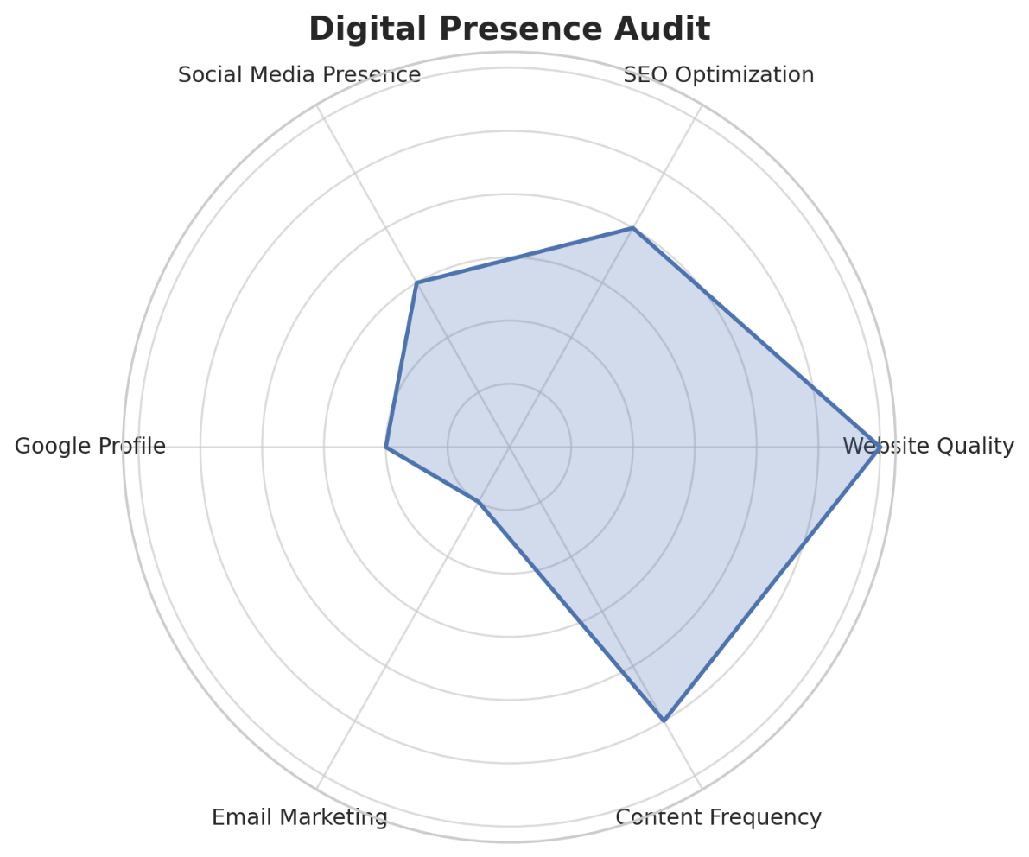

# Performance Test

This is very important part and defines why this work is meant of Real industries, instead of being just academic project.

Here we need to first find the constraints.

How those constraints were taken care in your design?

What were test results around those constraints?

Constraints can be e.g. memory, MIPS (speed, operations per second), accuracy, durability, power consumption etc.

In case you could not test them, but still you should mention how identified constraints can impact your design, and what are recommendations to handle them.

# My learnings

Working on this digital marketing project gave me a lot of practical insights — not just about marketing strategies, but also about problem-solving, working with real data, and understanding how small businesses operate in the digital world.

**1. Real-World Application of Marketing Concepts**

I learned how to take theoretical concepts like SEO, content marketing, and customer targeting — and actually apply them to a real business scenario. It helped me understand how different channels work together to build an online presence.

**2. Importance of Strategy Over Tools**

Instead of jumping straight into tools or platforms, I learned to first define the **problem clearly**, understand the audience, and then design a strategy that’s realistic and actionable. This approach made the entire solution more sustainable.

**3. Hands-On Use of Digital Tools**

Through this project, I became confident using essential tools like:

* Google Analytics and Search Console for tracking and performance monitoring
* Canva for content design
* Google Business Profile for local SEO
* Mailchimp (or equivalent) for simple email marketing flows

These are tools I can now apply across industries and projects.

**4. Data Interpretation & Decision Making**

Analyzing engagement data, identifying which content worked, and adjusting strategies accordingly taught me how **data should guide marketing decisions**. It’s not just about being creative — it’s also about being data-driven.

**5. Communication & Presentation Skills**

Since I had to translate technical findings and strategies into simple terms for a business audience (or a mentor), I learned how to explain things clearly and professionally — a crucial skill in any job or freelance role.

**6. Empathy for Small Business Challenges**

I realized that many small businesses aren’t failing because they’re not good — they just don’t have the time, knowledge, or money to manage digital marketing effectively. That insight shaped how I approached the solution — making it simple, low-cost, and easy to manage.

# Future work scope

* Integration of Data Science / Machine Learning Models
* Automation of Marketing Tasks
* Multilingual or Regional Targeting
* Advanced Analytics & Dashboards
* E-commerce or App-Based Expansion
* A/B Testing & Experimental Campaigns
* Collaboration with Other Domains
* Scaling to New Platforms and Channels
* Continuous SEO & Content Optimization